Lab Examination Question Paper

Course Name: DABC | Batch: March 2012 | Module Name: Network Computing
Date: 20 Apr 2012 | Duration: 90 Minutes | Max. Marks: 40
Set-2

Instructions: Please read the question carefully

1. Write a DTD for an XML document type that should store the marks attained by each student on each module they take. Each student has a title (Mr, Mrs, Ms or Miss), a name, and an email address (which is guaranteed to be unique). For each mark it is sufficient to associate it with a module code (e.g. CC213), it is not necessary to give any further details of the module.

Write an XML document that conforms to the DTD you wrote for part
2. Create the Schema and DTD for the following the XML Document
<cricket>
<testmatch>
<SouthAfrica>
<firstmatch>SA won by an innings and 21 runs</firstmatch>
<secondmatch>match drawn</secondmatch>
<thirdmatch>match drawn</thirdmatch>
<fourthmatch>SA won by an innings and 37 runs</fourthmatch>
<fifthmatch>England won by 2 wickets</fifthmatch>
</SouthAfrica>
<zimbabwe>
<firstmatch>No test matches</firstmatch>
</zimbabwe>
</testmatch>
<OneDayInternationals>
<SouthAfrica>
<firstmatch>Jan 23rd</firstmatch>
<secondmatch>Jan 26th</secondmatch>
<thirdmatch>Jan 28th</thirdmatch>
<fourthmatch>Jan 30th</fourthmatch>
<fifthmatch>Feb 4th</fifthmatch>
<sixthmatch>Feb 9th</sixthmatch>
</SouthAfrica>
<zimbabwe>
<firstmatch>Feb 16th</firstmatch>
<secondmatch>Feb 16th</secondmatch>
<thirdmatch>Feb 16th</thirdmatch>
<fourthmatch>Feb 16th</fourthmatch>
</zimbabwe>
</OneDayInternationals>
</cricket>

3. Create the DTD and the XML document for the a Catalog use the following figure:
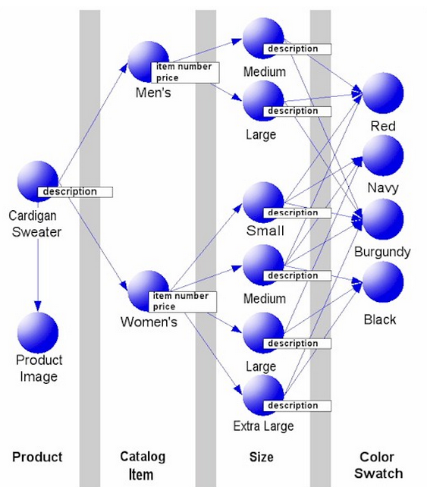

Follow the hierarchy and design the XML, here Product, Catalog Item, Size, Color Swatch are the elements.

